Causes of Great Depression Questions

1. Fill in the chart below:

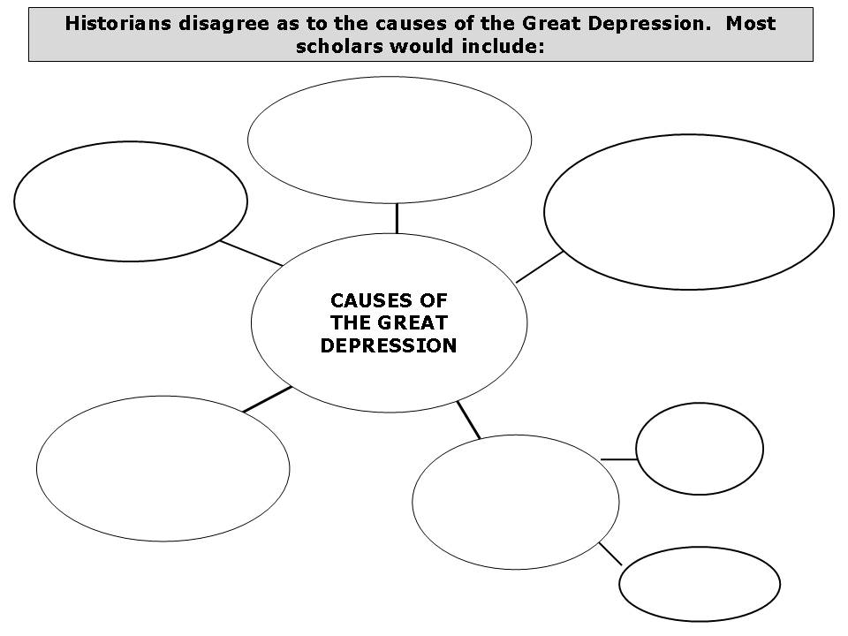
2. The 1920s was not a prosperous time for everyone. Explain.
3. Where was poverty a serious problem: in the cities or countryside?
4. What did 80% of Americans not have?
5. In your own words define disposable income.
6. Who gained the most income in the 1920s?
7. Total realized income rose by _______ from 1923-1929.
8. How would you describe what happened to unskilled wages from 1920 to 1930?
9. Why did Europeans not pay back the money they borrowed during WWI?
10. Explain the results of the Fordney-McCumber Act.
11. List several problems that resulted from overproduction.
12. Why did problems in agriculture have a great impact on the American economy as a whole? Why would it probably not have such a great impact today?
13. Describe what happened to farm prices from 1912 to 1933.
14. Why were many voters suspicious of Al Smith?
15. Why was Hoover so popular?
16. What did Hoover claim was vanishing in 1928?
17. Explain what self-reliance means.
18. What did Hoover consider the most urgent economic problem?
19. Why did many farmers lose their farms?
20. How much did the price of wheat drop between 1919 and 1932? What did this mean for wheat farmers?
21. Explain foreclosure.
22. Explain why the Federal Reserve was created.
23. How did the Federal Reserve react at the beginning of the Great Depression?
24. Define speculating.
25. List four reasons for the 1929 stock market crash.
26. What decade did this PowerPoint cover?
27. If you had been president in the 1920s what steps would you have taken to prevent the Great Depression?
28. Explain Hoover’s philosophy of government and why this would lead to widespread unemployment, homelessness and hunger when the depression began.

Answer Key
Agriculture
Industry
Over Production
Unequal distribution of wealth
Monetary policy
Stock market crash and financial panic
High Tariffs and war debts

1.

2. Farmers were in a depression throughout the decade.
3. Countryside or rural areas.
4. No savings.
5. Leftover money after the bills are paid.
6. Top 1%.
7. $14.7 billion.
8. Stayed about the same.
9. Broke after the war.
10. European nations retaliated with tariffs and world spiraled into depression.
11. Workers could not afford new products because wages too low, could not sell extra to other nations due to tariffs.
12. 30% of Americans still lived on farms. Most people live in cities.
13. Dropped tremendously.
14. He was Catholic.
15. He fed starving Europeans after WWI.
16. Poverty.
17. Taking care of yourself.
18. Agriculture.
19. Wholesale food prices dropped and could not afford new equipment and could not afford their mortgages.
20. $178.40. They were broke.
21. The bank repossesses a property after unpaid mortgages.
22. To keep the economy stable through a central banking system.
23. Did nothing to help banks.
24. Making risky purchases in hopes of striking it rich, even though the investment is questionable.
25. Overpriced stocks, fraud and illegal activity, margin buying, and Federal Reserve policy.
26. 1920s
27. Answers will vary: help banks, more help for farmers, protect mortgages with loans from the government, etc.
28. Answers will vary but might include: he believed in a limited role of government and in particular little involvement in helping people in trouble.

